**Create a website in PhP & MySQL using LAMP Stack.**

1. **Setting up the Apache server**

* Download and install apache2 from ubuntu

1. sudo apt update

2. sudo apt install apache2

* Change firewall settings to allow traffic

1. sudo ufw app list

2. sudo ufw allow in "Apache Full"

* See if you can access this server by putting the following in your browser: http://server_ip where server_ip is your ip_address of server machine, get this using ifconfig in your terminal and copying the ipv4 address

Note: You can also directly access the webpage by using: <http://localhost>

* You should see the following image:

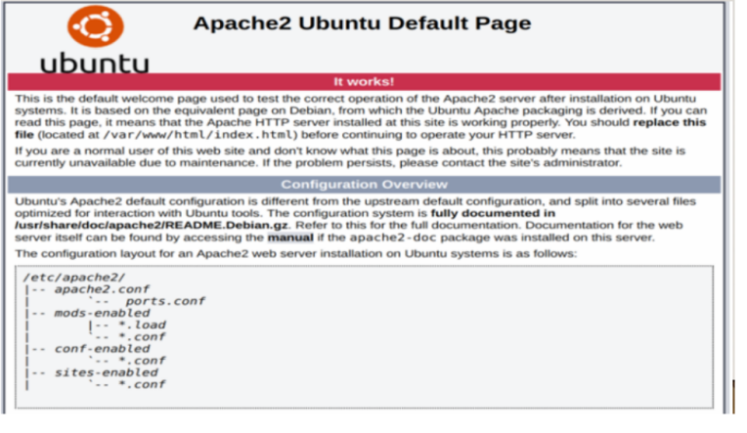

1. **Setting up MySql server**

* Download and install mysql: sudo apt install mysql-server
* Set up secure installation.

If you try to run secure installation directly, you might encounter error related to password for root, as such refer to the steps below first.

1. sudo mysql-logs in as root

2. inside mysql prompt run, ALTER USER 'root'@'localhost' IDENTIFIED WITH mysql_native_password by 'mynewpassword' replacing mynewpassword with what you want

3. Now run sudo mysql_secure_installation

* Login to mysql server now using: sudo mysql -u root -p followed by entering the password you set up above.

1. Installing PHP Download php compatible with apache2 and mysql

* sudo apt install php libapache2-mod-php php-mysql
* Check if installation was successful by running: php -v You should see the following:

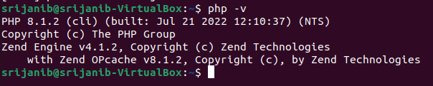

* Make .php pages have higher priority over .html pages for the apache server

1. sudo nano /etc/apache2/mods-enabled/dir.conf

2. This file looks as follows

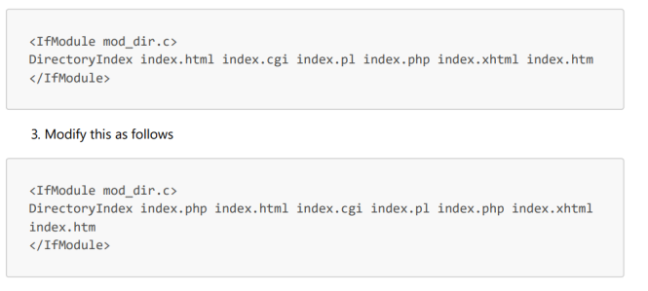

4. **Create a virtual host for your website**

* First navigate to /var/www and create a new folder named your domain and add index.html to it.

1. sudo mkdir /var/www/your_domain

2. sudo chown -R $USER:$USER /var/www/your_domain

3. sudo nano /var/www/your_domain/index.html

4. Inside the html file add the following :

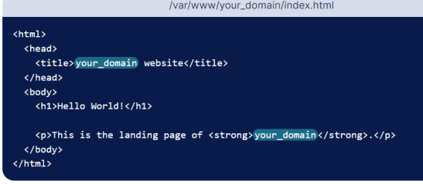

* Navigate to ‘/etc/apache2/sites-available/ and add a new configuration for this domain

1. sudo nano /etc/apache2/sites-available/your_domain.conf

2. Inside this file, add the following :

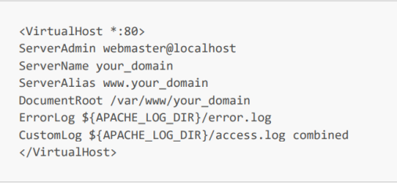

* Enable this configuration

1. sudo a2ensite your_domain.conf

2. sudo a2dissite 000-default.conf

3. sudo apache2ctl configtest

4. sudo systemctl restart apache2

**Congratulations!!! The lamp stack is now setup, now lets setup our website**

Contents:

-index.php, add.php,delete.php,connect.php,style.css,update.php

Database: event_database

Tables: event_list

Contents:

Database:

student_id INT AUTO_INCREMENT PRIMARY KEY, name VARCHAR(30),email VARCHAR(50),event_name VARCHAR(40)

Implementation:

        => Install all packages required for Apache, MySQL and php on Ubuntu and configure it.

        => Check Apache configuration by going to "localhost" on broswer, Apache Landing page will be visible

        => Place the files in the directory "/var/www/event_management_system " and assure mysql and apache services are running

        => Type "localhost/index.php" in the web browser to access the web application

Code Structure

        => The default page containing the structure of application is index.php which contains the required HTML styled by

              custom css file style.css, PHP connects with MySQL in connect.php with required

              credentials and add.php is php snippet to handle post request of adding new task to database,

              delete.php is php snipped to handle post request to delete a task by ID in database.

WEBSITE:

ADD:

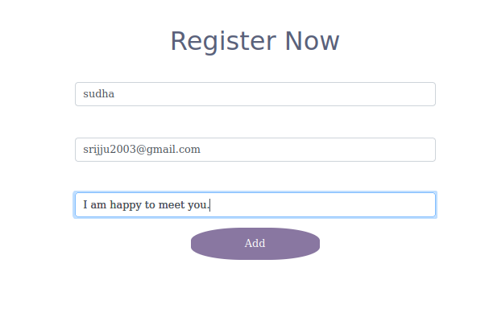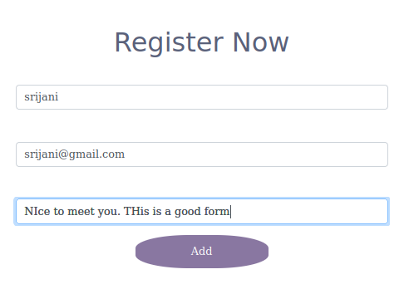

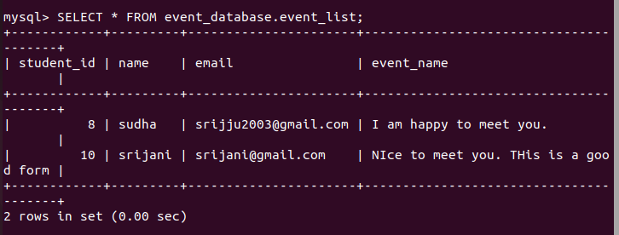

DELETE:

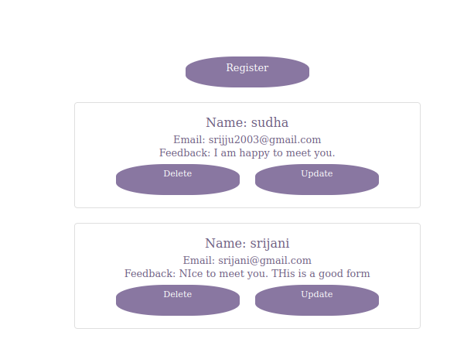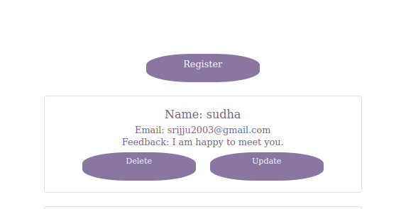

UPDATE:

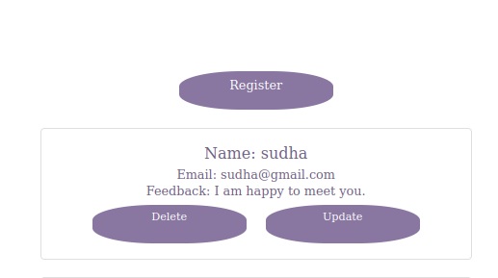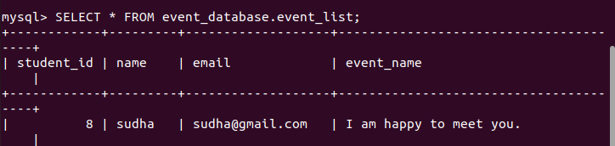

SRIJANI BHEEMARAPU

BT20CSE128

SL LAB 3 ASSIGNMENT 1 Q1id INT AUTO_INCREMENT PRIMARY KEY, name VARCHAR(40), message VARCHAR(50)